**MIDDLE EAST TECHNICAL UNIVERSITY**

**DEPARTMENT OF ELECTRICAL AND ELECTRONICS ENGINEERING**

**EE101: Introduction to Electrical and Electronics Engineering  
MATLAB Hands-on Exercise Session Report**

**Name : Alperen Öztürk  
Student ID : 2575868**

**Part I: Overview of Basic Tools**

* Write down the values of ***m*** and ***n*** and briefly explain what they represent.

The values of m and n represent the index values of the elements that are equal to 0 in A matrix, and here the m represents the row indices , n represent the column indices of each element.

For example, the second entry of A that is equal to 0 is in the first row, and in the second column. Because of that, first value of m is 1 and first value of n is 2.

* Comment on the difference between the two product operators “ * ” and “ .* ”.

* is used for matrix multiplications.

.* is used for element-wise multiplications. For example, Axy * Bxy

* Insert the plot you saved in Part I Ex. 10 below.

çizelge içeren bir resim

Açıklama otomatik olarak oluşturuldu

**Part II: Frequency Analysis of Sinusoidal Signals**

* Insert the plot you saved in Part II Ex. 2 below.

çizelge içeren bir resim

Açıklama otomatik olarak oluşturuldu

* Insert the spectrum plot you saved in Part II Ex. 5 below.

çizelge içeren bir resim

Açıklama otomatik olarak oluşturuldu

* Can you approximately spot the dominant frequency ***f0*** in the signal ***x***? Interpret this by remembering that our signal is $x\left(t\right)=sin⁡(ω_{0}t)$. What is the relation between ***ω0*** (the angular frequency in radians per second) and ***f0***(the frequency in Hertz)?

Dominant frequency is approximately 1 Hz. The relation between ***ω0*** and ***f0*** is, ***ω0*** = 2*π* ***f0.***

* Report the dominant frequencies in the signal ***x*** and comment on the result. Is the function output consistent with the frequency ***f0*** you determined in part 5?

There is just one dominant frequency in the signal x and it is 0.998 Hz. It shows that it is consistent with the dominant frequency I determined in part 5.

* Insert the plot of ***y(t)*** you saved in Part II Ex. 8 below.

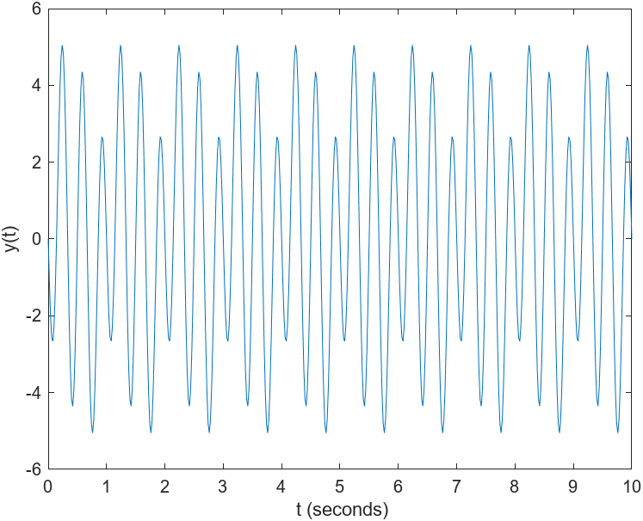

* In what way do ***x(t)*** and ***y(t)*** have similar and different characteristics?

They both have sinusoidal characters; however, y(t) consist 3 different sinusoids.

Y-Axis limits of y(t) are 6 and -6,but since there is no such t that makes the first two elements of y equal to 1 and last element equal to -1, y(t) never reach 6 and -6.

Y-Axis limits of x(t) are 1 and -1 and x(t) which consists one sinus function, and x(t) oscillates between 1 and -1

* Inspect the spectrum of ***y(t)*** and comment. What are the dominant frequencies in ***y(t)*** in units of Hz? Comment on how these are related to the angular frequencies ***w0***, ***2w0***, ***3w0*** of the three sinusoids making up the signal.

There are 3 peaks on the spectrum of y(t),and they represent the 3 different dominant frequencies. These frequencies are 0.9980 Hz, 1.9960 Hz, 2.9940 Hz, and they are directly proportional with the angular frequencies ***w0***, ***2w0***, ***3w0.***  This proportion results from the formula ***ω0*** = 2*π* ***f0.*** When the angular frequency is multiplied by a constant, so does the frequency must be multiplied by that constant.